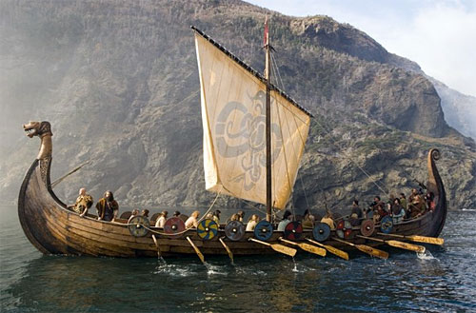
Oak Autumn Term 2024 Mr. Pugh

Science
Living Things and their Habitats
Materials and their Properties

MFL
Weather, colours, shopping, instructions. Speaking, listening reading, and writing activities used for all topics.

Music
Duration
How Does Music Connect Us with Our Past?

English
Shared, group and silent reading
Spelling rules
Sentence construction and punctuation
Grammatical awareness
Drama
Speaking and listening skills

Fiction and poetry

Extended Blog entry-Leila and the Blue Fox
Extended narratives-The Arrival

Non-Fiction
All non-fiction writing will taught through topic work
Discussion texts
Newspaper articles
P.E.

Gymnastics
Invasion games
P.E. and Games will be every Thursday afternoon.
P.E. kit should include T-shirt, shorts and daps or bare feet. Games kit should include trainers and sweatshirt.
R.E.
Exploring aspects of Hinduism
Harvest
Christmas
Design and Technology
Cooking: Seasonal Food



The Vikings are coming!
Our topic for this term is the Vikings and Anglo-Saxons struggle for power. We will investigate: Who were the Vikings and Anglo Saxons? Why did the Vikings come to Britain? Who was Alfred the Great and why is he remembered in British history?
Living in America
Where is the USA? What is the landscape and weather like there? Where do the people live? How do Americans cope with natural disasters? How is the land used for food and farming?
The majority of work covered this term will be linked to this topic.

Computing
Children will be learning about how the Internet works and how to write their own programs.

Mathematics
Place value
Mental calculation: addition, subtraction, multiplication and division.
Written methods +/-/x/÷
Money and ‘real life’ problems
Problem solving
Statistics
Measurement: area and perimeter

Art
Drawing skills, painting and printing
Artist in focus: Seurat and Keith Haring
Viking art and craft.
P.S.H.E.
New beginnings
Getting on and falling out

